**Enhance PDFs with Multi-Line Text Boxes**

Syncfusion Essential® PDF offers a high-performance [.NET library](https://www.syncfusion.com/document-processing/pdf-framework/net-core) that allows you to create, read, and edit PDF documents efficiently. This guide demonstrates how to add a multi-line text box using the [PdfTextBoxField](https://help.syncfusion.com/cr/document-processing/Syncfusion.Pdf.Interactive.PdfTextBoxField.html) in a PDF document

**Steps to add a multiline text box in PDF document**

1. **Create a Console Application**: Start by setting up a new console application project in your development environment.

2. **Add Syncfusion NuGet Package**: Install the [Syncfusion.Pdf.Net.Core](https://www.nuget.org/packages/Syncfusion.Pdf.Net.Core/) package from NuGet to your project.

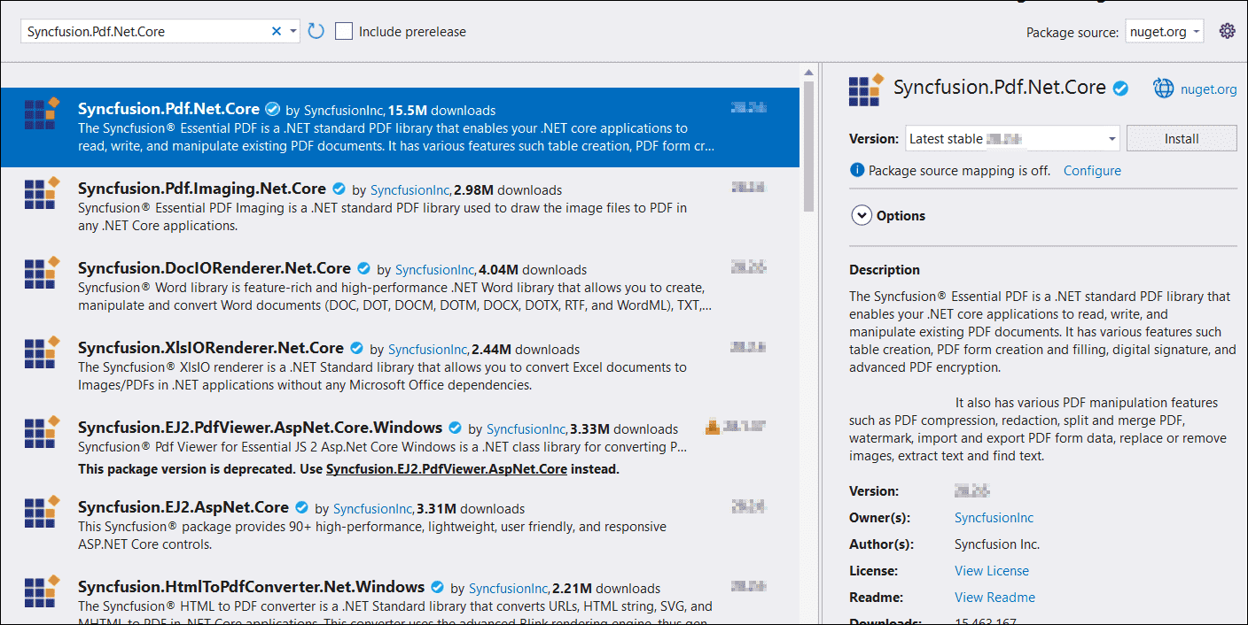

3. **Include Required Namespaces**: In the **Program.cs** file, add these namespaces

**C#**

|  |
| --- |
| **using** Syncfusion.Pdf;  **using** Syncfusion.Pdf.Graphics;  **using** Syncfusion.Drawing;  **using** System.IO; |

4. **Implement Multi-Line Text Box**: Use the following code to create a multi-line text box in your PDF document

**C#**

|  |
| --- |
| // Create a new PDF document  PdfDocument document = new PdfDocument();  // Creates a new page and adds it to the document  PdfPage page = document.Pages.Add();  // Create a standard font to be used in the text field  PdfFont font = new PdfStandardFont(PdfFontFamily.Courier, 12f);  // Create a text box field and add it to the page with a name  PdfTextBoxField textBoxField = new PdfTextBoxField(page, "FirstName");  // Set the bounds (position and size) of the text box field  textBoxField.Bounds = new RectangleF(0, 0, 200, 50);  // Enable multiline functionality for the text box (allows multiple lines of text)  textBoxField.Multiline = true;  // Set the initial text inside the text box field  textBoxField.Text = "Essential PDF allows you to create and manage the form (AcroForm) in PDF document by using PdfForm class. The PdfFormFieldCollection class represents the entire field collection of the form.";  // Add the text box field to the form field collection in the document  document.Form.Fields.Add(textBoxField);  // Create a FileStream to save the document  using (FileStream stream = new FileStream("Output.pdf", FileMode.Create, FileAccess.Write))  {  // Save the PDF document to the file stream  document.Save(stream);  }  // Close the document  document.Close(true); |

A complete working sample can be downloaded from [**GitHub**](https://github.com/SyncfusionExamples/PDF-Examples/tree/master/Forms/Creating-a-Multiline-Text-Area-in-PDF/.NET).

Take a moment to peruse the [**documentation**](https://help.syncfusion.com/document-processing/pdf/pdf-library/net/working-with-forms) to learn how to add form fields in a PDF document.

**Conclusion**  
I hope you enjoyed learning how to add a multi-line text box field to a PDF document.

You can refer to our [**ASP.NET Core PDF feature tour**](https://www.syncfusion.com/document-processing/pdf-framework/net-core) page to know about its other groundbreaking feature representations and [**documentation**](https://help.syncfusion.com/document-processing/pdf/pdf-library/net/create-pdf-file-in-asp-net-core), and how to quickly get started for configuration specifications. You can also explore our [**ASP.NET Core PDF example**](https://ej2.syncfusion.com/aspnetcore/PDF/Default#/bootstrap5) to understand how to create and manipulate data.

For current customers, you can check out our components from the [**License and Downloads**](https://www.syncfusion.com/sales/teamlicense) page. If you are new to Syncfusion, you can try our 30-day [**free trial**](https://www.syncfusion.com/downloads/aspnetcore-js2) to check out our other controls.

If you have any queries or require clarifications, please let us know in the comments section below. You can also contact us through our [**support forums**](https://www.syncfusion.com/forums), [**Direct-Trac**](https://support.syncfusion.com/create), or [**feedback portal**](https://www.syncfusion.com/feedback/aspnet-core?control=pdf). We are always happy to assist you!